**Foreword**

Our current service has 3 outlets - web, android app and iOS app. For the demo task, you should implement the changes on web only, and when confirmed from our end, you may reflect the changes on the app and deploy. Ionic Appflow is implemented as follows;

1.⁠ ⁠Go to appflow dashboard

2.⁠ ⁠Select commit for build

3.⁠ ⁠App build is submitted on store.

Also, please note that soft update is enabled on Appflow, so we can bypass app store review for minor updates. Appflow credential will be provided later.

**Demo Task(s)**

1. Slate JS: we are currently using slate js for our RTE, but with basic input. We need to implement a RTE for role = admin || management, as well as allowing users to insert media within post.

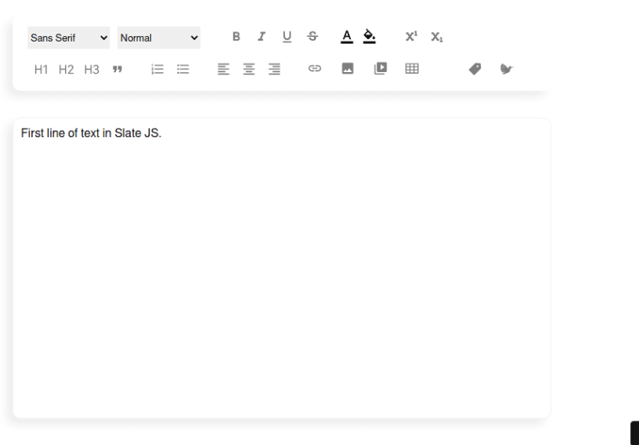

* Do not use other RTEs, or install dependencies without discussing with your PM.
* Only {bold, italic, underline, strikethrough, font color, background color, numbering, bulletpoint, indent (Left, center, right), link, insert image, insert video} is needed. Not all options in the image above^
* Current “@ Mention” needs to be intact & seamlessly integrated.
* Current Media upload should be intact & seamlessly integrated.
* This is only for Post Write, Not Comment Write.

1. Merge PR, Build & deploy via Appflow.

**Afterword**

Your qualification will be reviewed based on:

1. Time spent vs output
2. Code quality (cleanness, concise, reusable)
3. Understanding of current code base

Once accepted, you will be immediately employed on **Freelancer** and given tasks after an intro meeting with PM. Access to Slack and full resources will be provided upon acceptance.